Development Setup Instructions:
- Use Development in LabVIEW 2021 SP1. Later versions will likely work just fine.
- Download “PathSolverSourceCode.zip” from google drive.
- This include all LabVIEW code for the physics engine, solver, and Robodot LabVIEW drivers.
- Extract Contents to My documents or wherever you want to develop from. Contents should be relative and work from wherever you would like.
- Download “Public Documents Data” and extract the contents to:
C:\Users\Public\Documents\
  - This is where the green data Is stored and the path solver will pull and write green data here.
- Python Dependency build:
  - Download “OvationGolfPython.zip” and extract contents to:
C:\Users\Public\Documents\
- Public Should look like this:
- 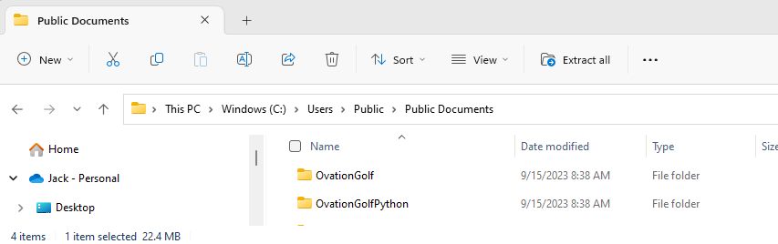
- The PathSolver exe and application build can be built from the following LabVIEW project:
"[your selected source path]PathSolverSourceCode\Putt Solver GUI\Project\Ovation Putt Solver Project.lvproj"

